

Card-Access 4K Milestone Access Control Plugin

Version 1.4

**Date: 01-20-2022**

**CardAccess4K Access Control Plugin**

CardAccess4K Access Control is customized of Milestone Access Control Plugin. The Doors can be manual controlled using this plugin. CardAccess4K Badge and Reader events shows to the event grid. Also, CardAccess4K Badges shows as cardholders.

**Prerequisites:**

1. CA4K version 1.1.5x.xxx or later must be installed.
2. CA4K RESTful API must be installed.

**NB:** Please confirm port 8081 is configured for both inbound and outbound. Make sure CA4K Application is up and running also check CA4K RESTful API by browsing API webpage (ex: <ip address>: 8081). IIS must be installed and configured same as CA4K web client installation, please refer ***CA4KWeb Installation and Configuration.pdf*** in documentation folder.

1. Download and install Milestone Management Client and Smart Client (64 bits) from bellow link

<https://www.milestonesys.com/downloads/?prod=1419&type=11&lang=27asdfasdf>

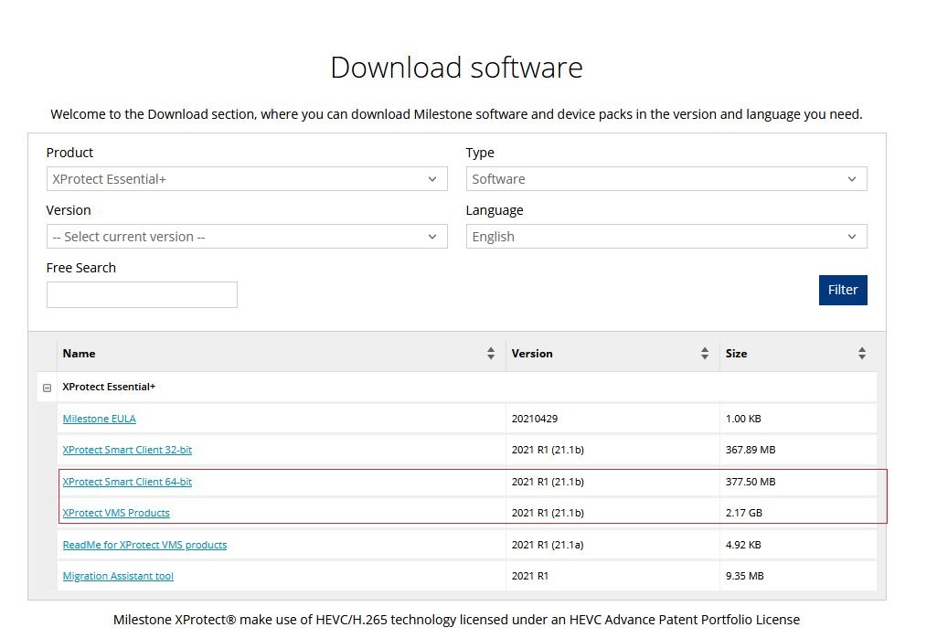

After completing installation installed service manager will show on the task manager. Run The Milestone Management Client and active the milestone access control license.

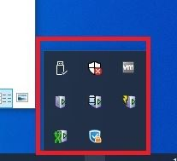

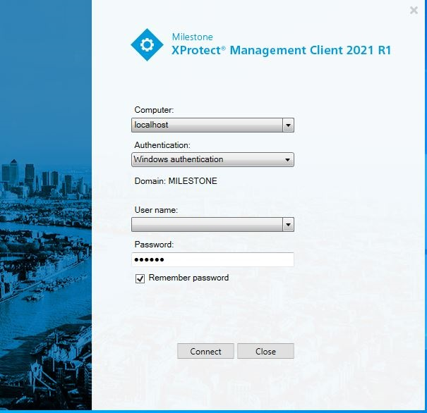

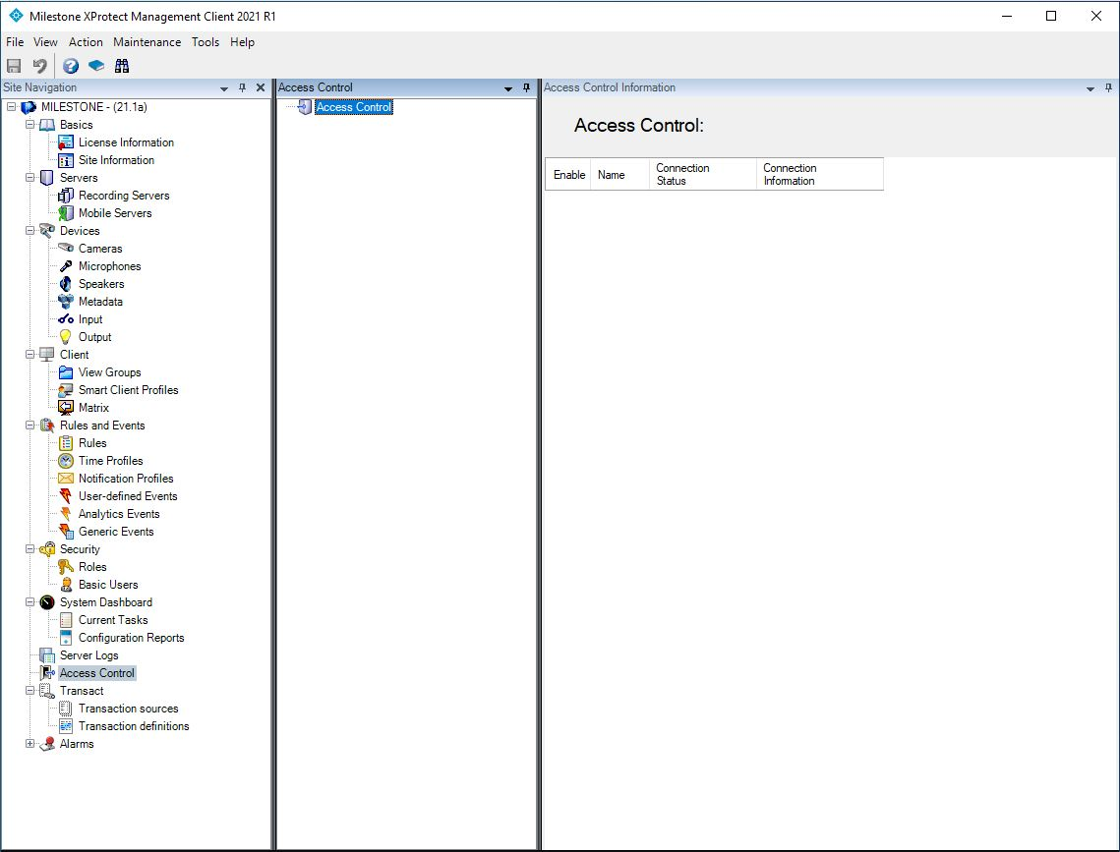

1. Stop the Milestone XProtect Event Server Service. Install the installer for Milestone Plugins from CA4K installer/VideoPlugins folder. After completing the installation start the Milestone XProtect Event Server Service.

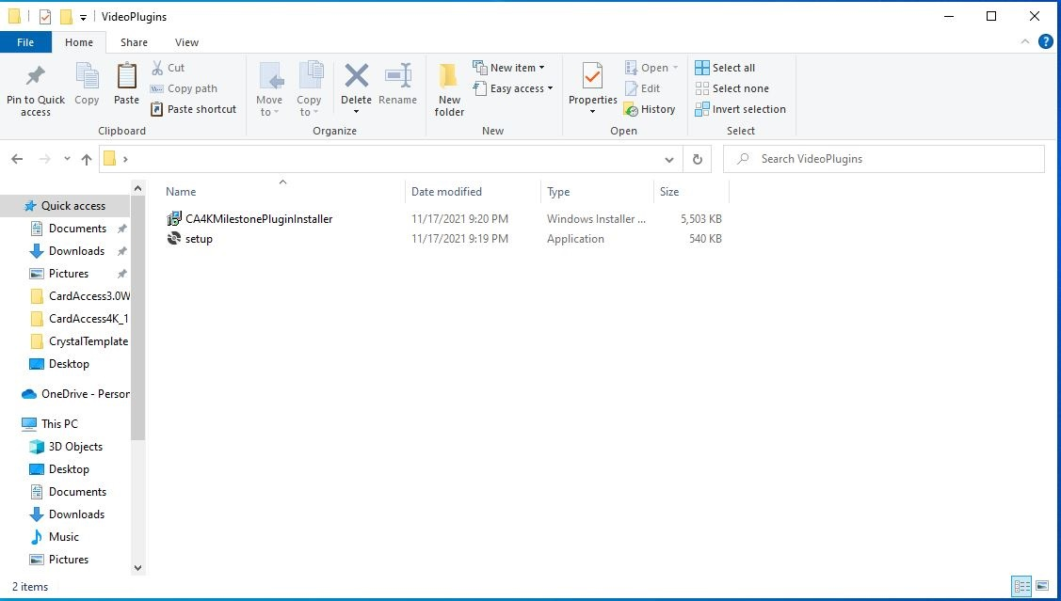

1. Refresh the Management Client (press F5), select Access Control, right click and click create a new

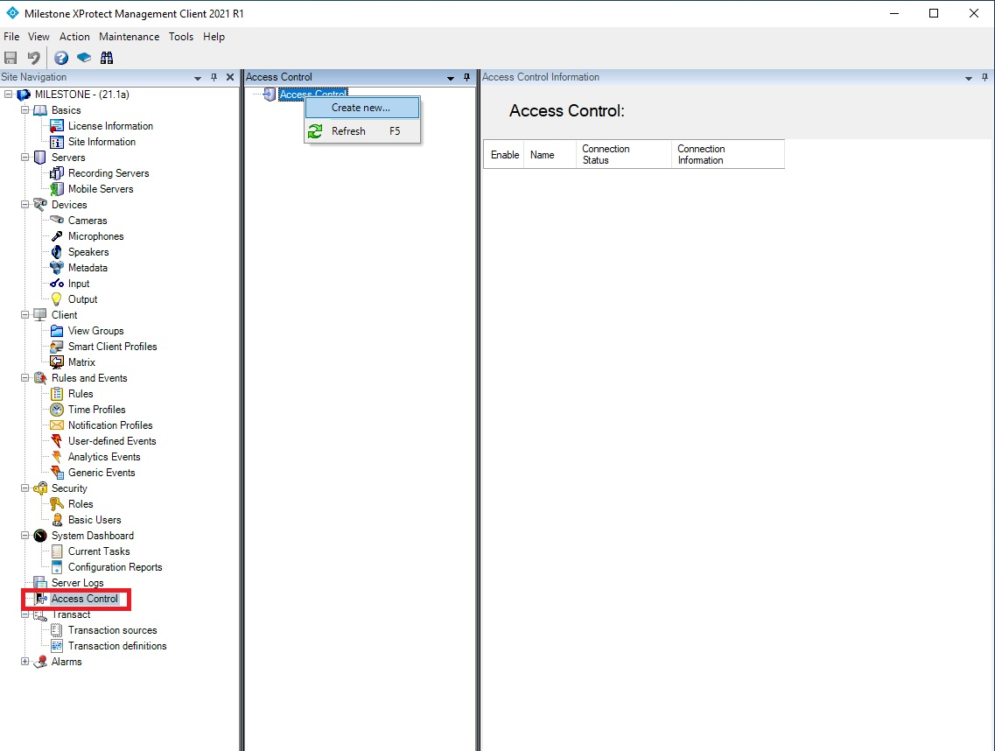

1. Create Access Control System Integration screen enter name and select CardAccess4K Access Control from integration plugin-in list, enter CA4K RESTful API IP address, port and user password. Click next.

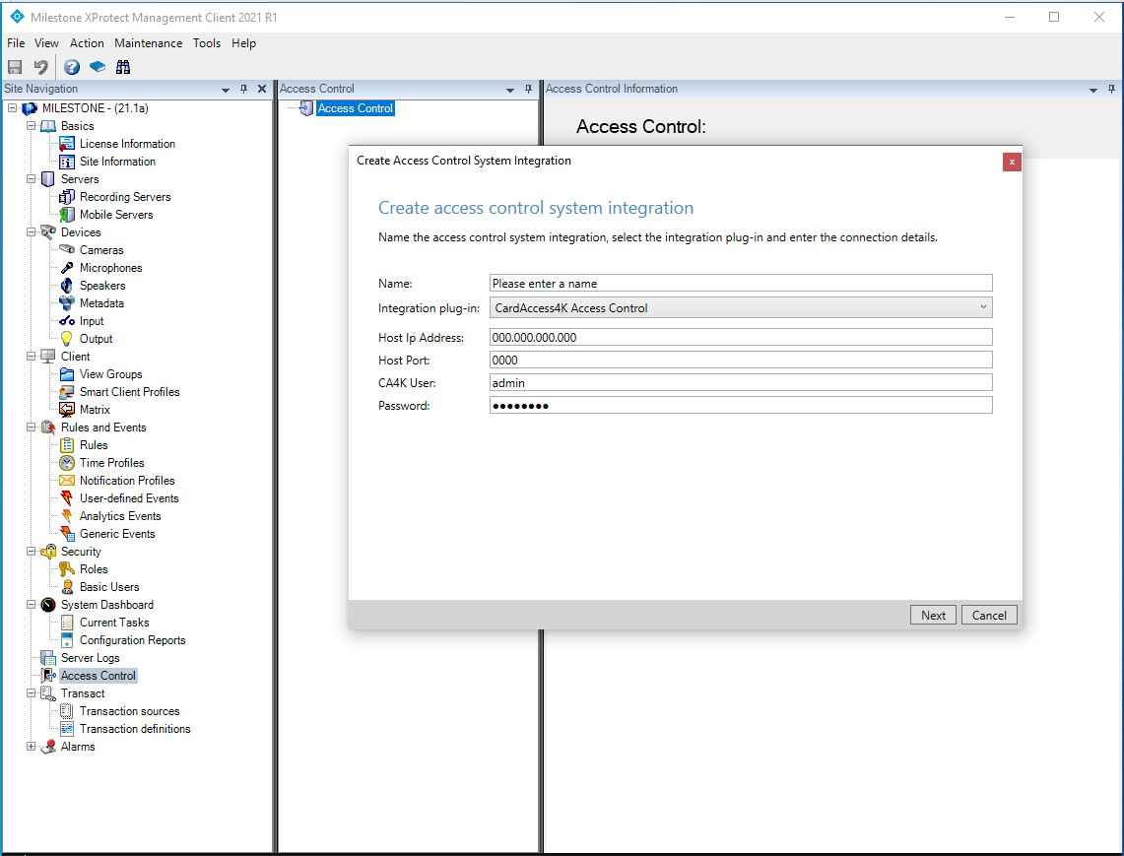

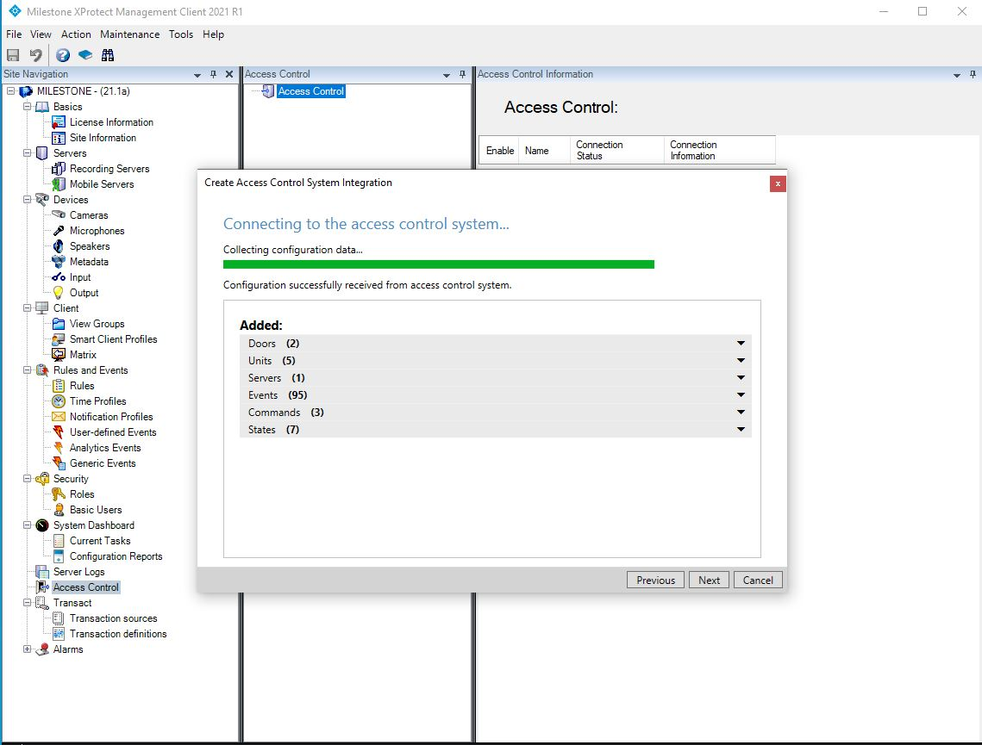

1. Select pre-configured camera from Milestone Recording Server and drug on the associate door in the door list. Click next and complete the configuration.

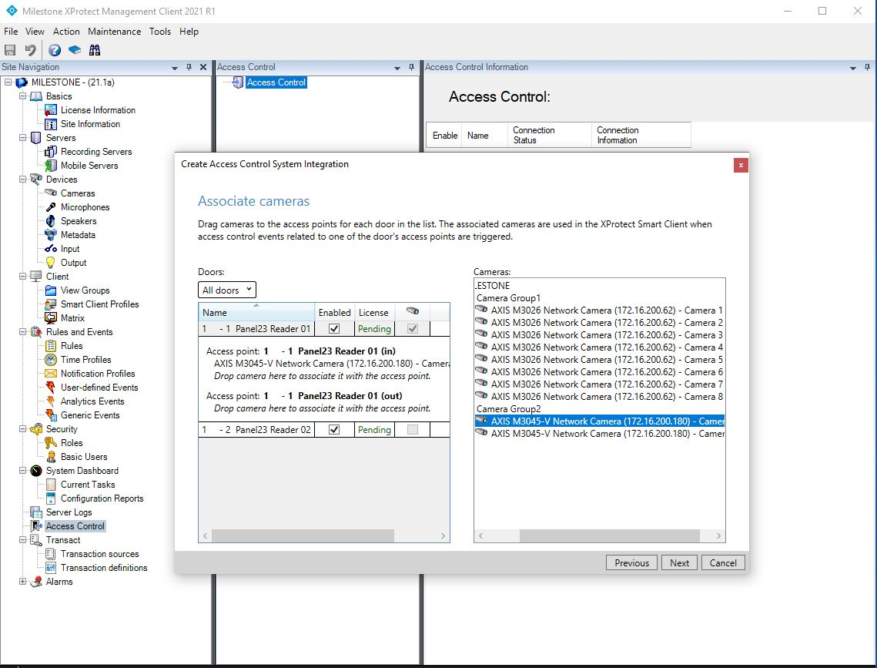

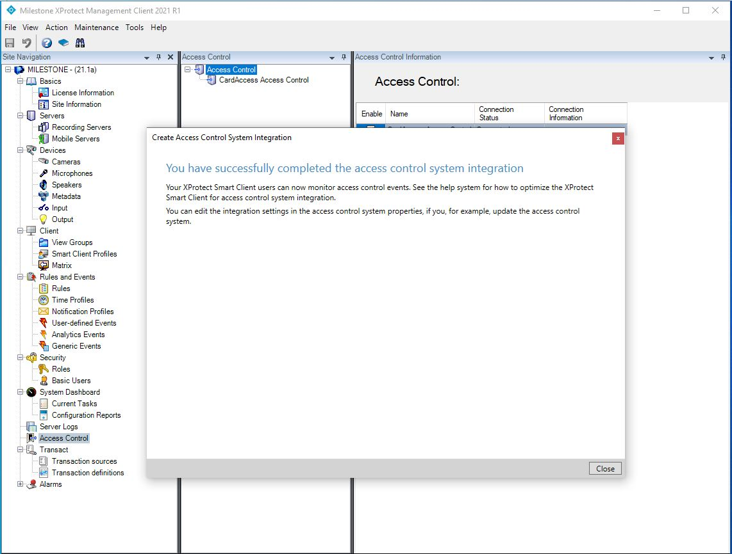

1. Access control will appear with minimum control tabs. For getting details info click Options from Tools menu.

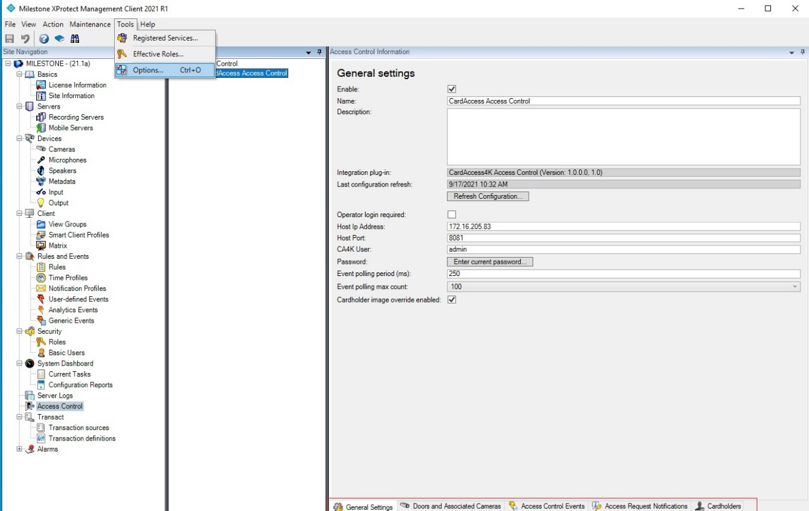

On the option screen select Access control settings tab and checked Show development properly panel and click Ok.

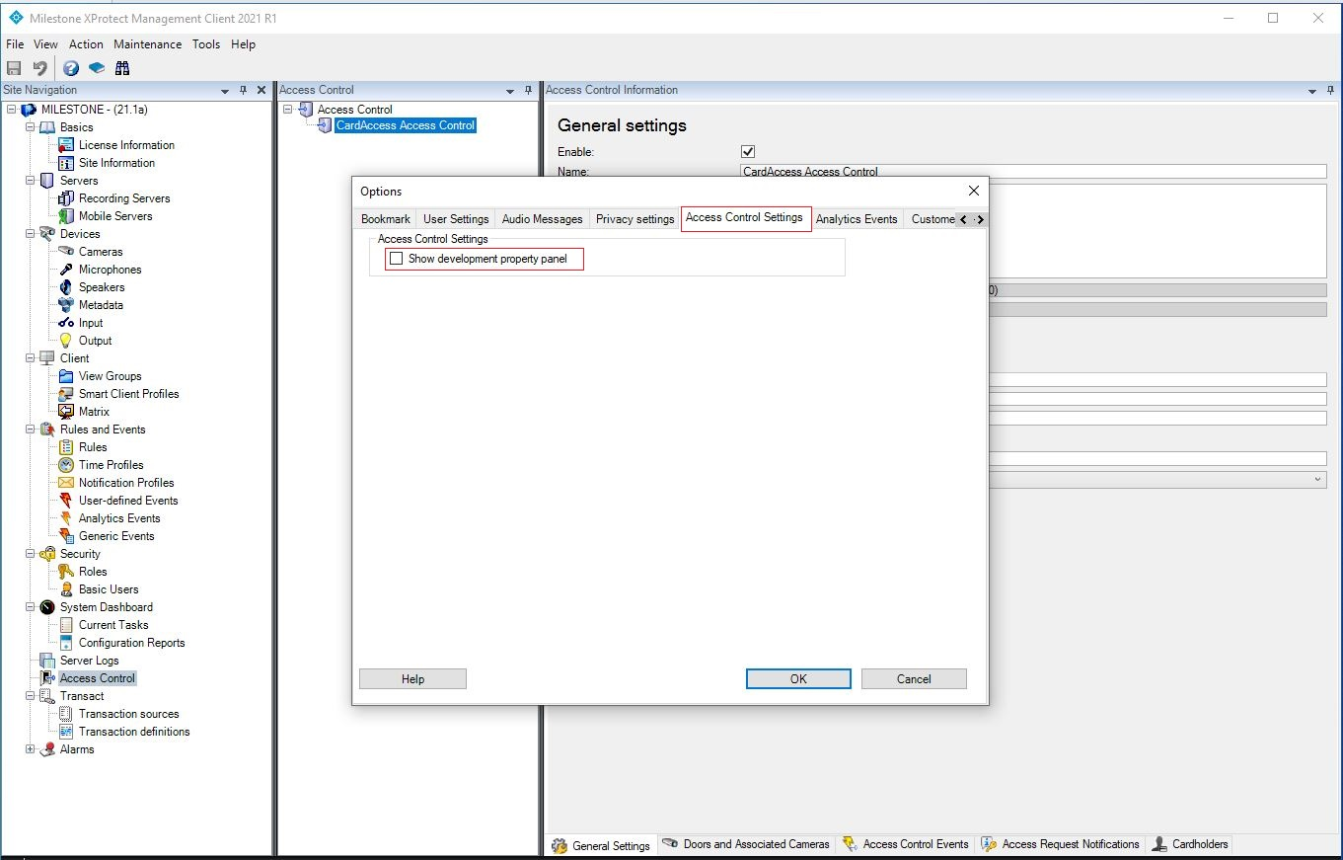

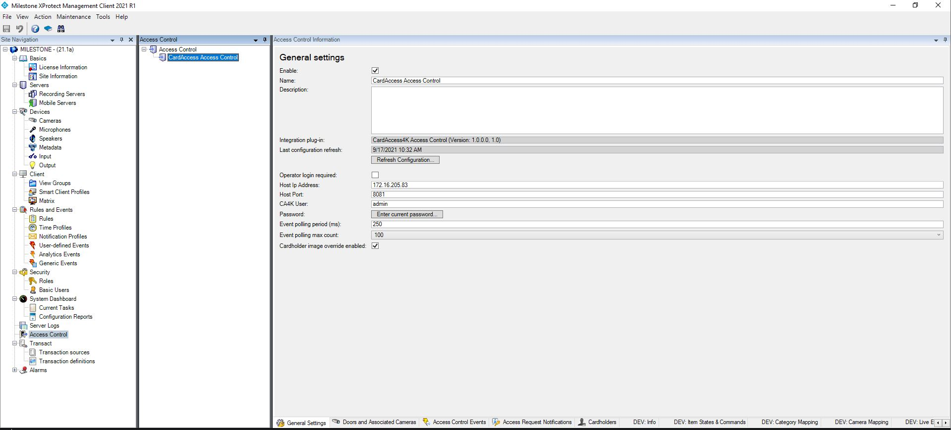

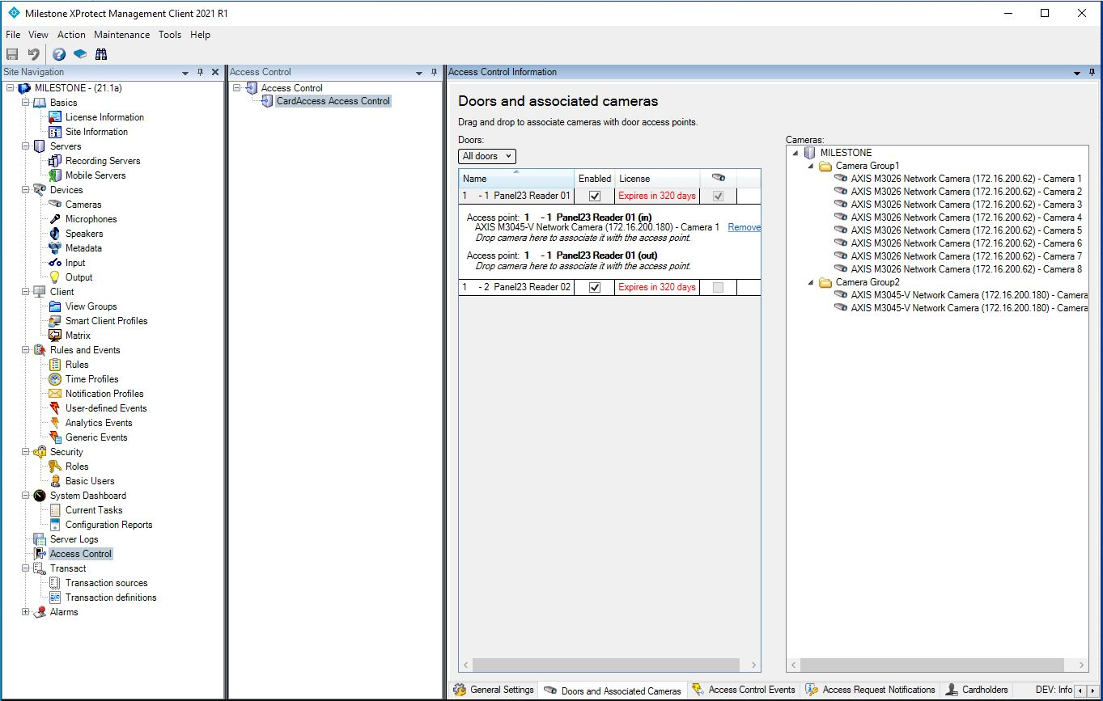

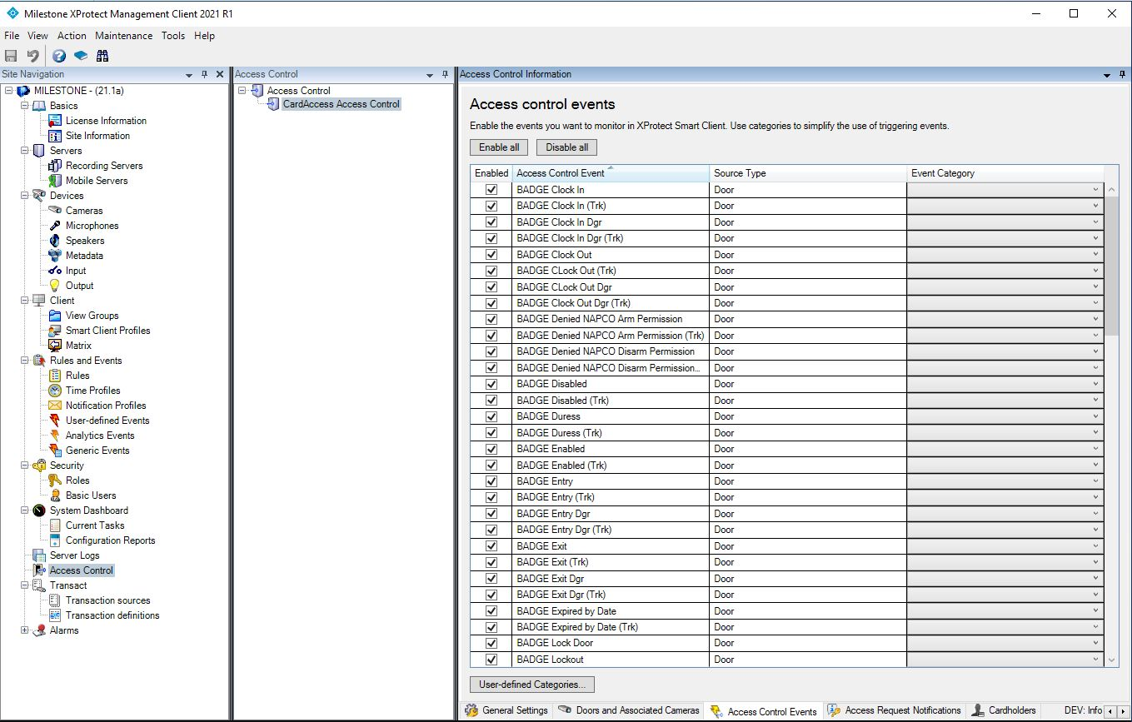

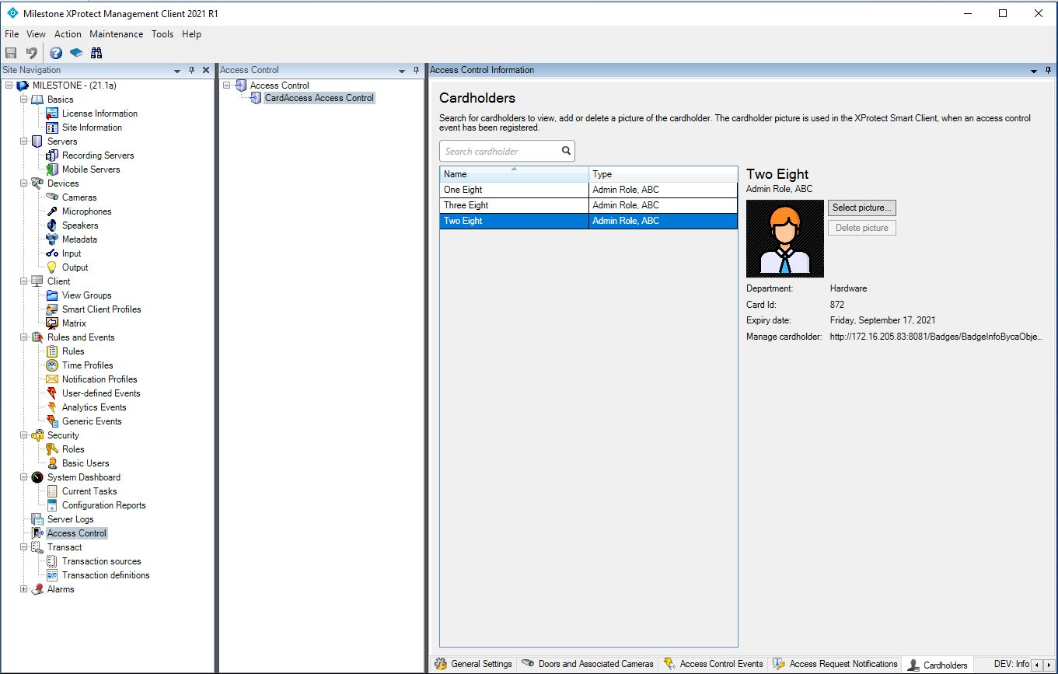

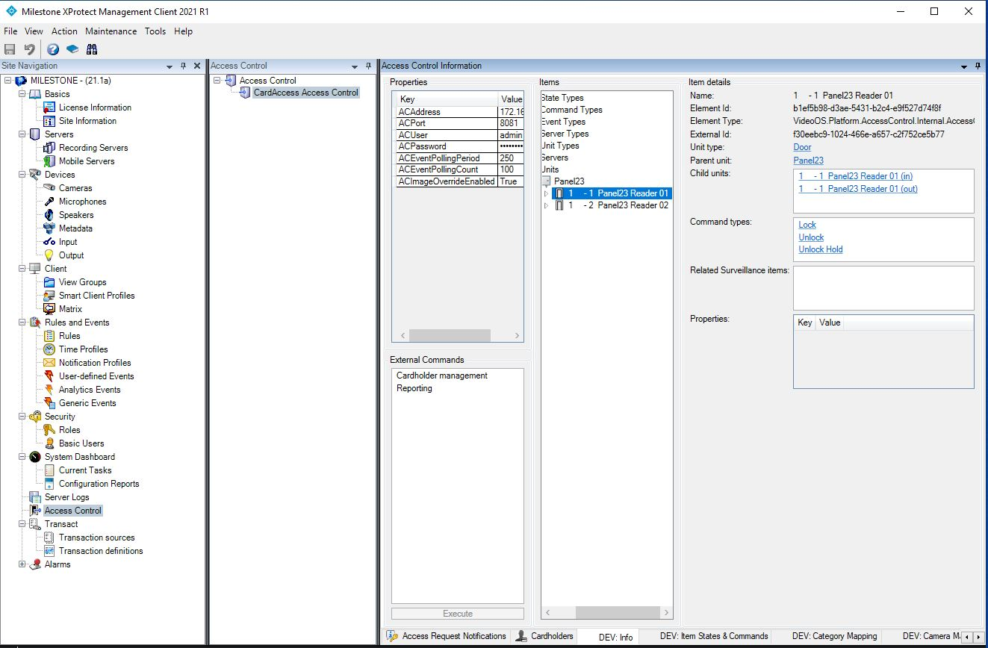

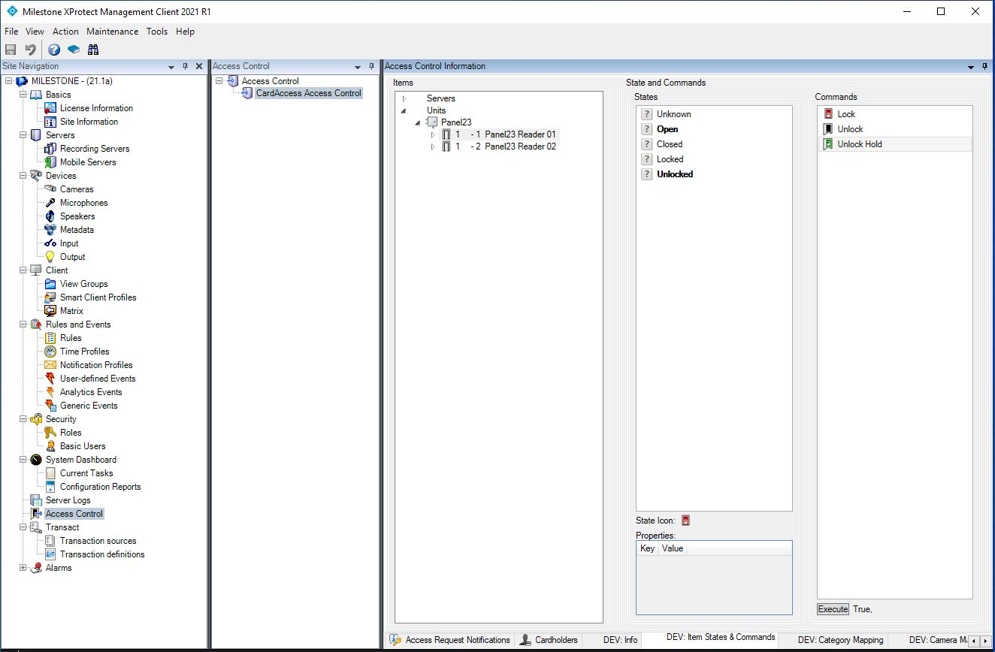

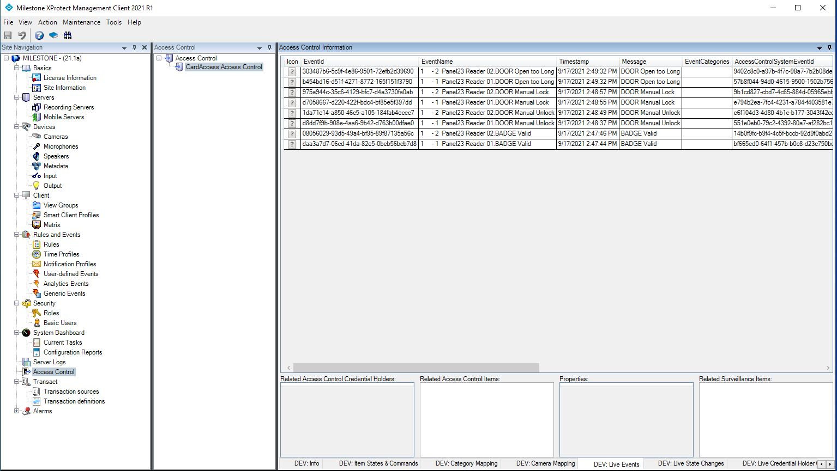

1. Run Milestone XProtect Smart Client. And select Access control Tab. Under the selected tab the sub tab of Events, Doors and Cardholders will show.

a). Initially CA4K Badge and Reader related events will show on the event grid.

b). On the Door sub tab. Select the door, manual control buttons, status and details will appear. User can control the door.

